

Semester Two Examination, 2020

Question/Answer booklet

MATHEMATICS

SOLUTIONS
METHODS
UNITS 1&2

Section One:

Calculator-free

WA student number: In figures

In words

Your name

Number of additional
answer booklets used
(if applicable):

Time allowed for this section
Reading time before commencing work: five minutes
Working time: fifty minutes

Materials required/recommended for this section
To be provided by the supervisor
This Question/Answer booklet
Formula sheet

To be provided by the candidate
Standard items: pens (blue/black preferred), pencils (including coloured), sharpener,
correction fluid/tape, eraser, ruler, highlighters

Special items: nil

Important note to candidates
No other items may be taken into the examination room. It is your responsibility to ensure that you do not have any unauthorised material. If you have any unauthorised material with you, hand it to the supervisor before reading any further.

Structure of this paper

Section | Number of  questions  available | Number of  questions to  be answered | Working  time  (minutes) | Marks  available | Percentage  of  examination
Section One:  Calculator-free | 8 | 8 | 50 | 52 | 35
Section Two:  Calculator-assumed | 13 | 13 | 100 | 98 | 65
 |  |  |  | Total | 100

Instructions to candidates

1. The rules for the conduct of examinations are detailed in the school handbook. Sitting this examination implies that you agree to abide by these rules.

2. Write your answers in this Question/Answer booklet preferably using a blue/black pen.
Do not use erasable or gel pens.

3. You must be careful to confine your answers to the specific question asked and to follow any instructions that are specific to a particular question.

4. Show all your working clearly. Your working should be in sufficient detail to allow your answers to be checked readily and for marks to be awarded for reasoning. Incorrect answers given without supporting reasoning cannot be allocated any marks. For any question or part question worth more than two marks, valid working or justification is required to receive full marks. If you repeat any question, ensure that you cancel the answer you do not wish to have marked.

5. It is recommended that you do not use pencil, except in diagrams.

6. Supplementary pages for planning/continuing your answers to questions are provided at the end of this Question/Answer booklet. If you use these pages to continue an answer, indicate at the original answer where the answer is continued, i.e. give the page number.

7. The Formula sheet is not to be handed in with your Question/Answer booklet.
Section One: Calculator-free 35% (52 Marks)
This section has eight questions. Answer all questions. Write your answers in the spaces provided.

Working time: 50 minutes.

Question 1 (6 marks)
Solve the following equations.

(a) $18x=25x-28$. (1 mark)
Solution
$$7x=28 \\ x=4$$

Specific behaviours
correct solution

(b) ${9x}^{2}=18x$. (2 marks)
Solution
$$9x^{2}-18x=0 \\ 9x\left(x-2\right)=0 \\ x=0, x=2$$

Specific behaviours
equates to $0$ and factorises
ü both correct solutions

(c) $x^{3}-9x^{2}-25x+33=0$. (3 marks)
Solution
When $x=1: \text{LHS}=1-9-25+33=0$

$$x^{3}-9x^{2}-25x+33=(x-1)(x^{2}+bx-33) \\ b-1=-9⇒b=-8$$
$$\left(x-1\right)\left(x^{2}-8x-33\right)=0 \\ \left(x-1\right)\left(x+3\right)\left(x-11\right)=0$$

$$x=1, x=-3, x=11$$

Specific behaviours
indicates that $x-1$ is a factor
ü determines quadratic factor
ü all three solutions

Question 2 (7 marks)
(a) Simplify $\sqrt{4^{-5}}$. (2 marks)
Solution
$$\sqrt{4^{-5}}={\left(\sqrt{4}\right)}^{-5} \\ =2^{-5} \\ =\frac{1}{32}$$

Specific behaviours
eliminates square root
ü correct fraction

(b) Write the value of $xy$ in scientific notation when $x=2.5×{10}^{3}$ and $y=5×{10}^{-7}$.
(2 marks)
Solution
$$2.5×5×{10}^{3}×{10}^{-7}=12.5×{10}^{-4} \\ =1.25×{10}^{-3}$$

Specific behaviours
obtains equivalent expression of form $a×{10}^{b}$
ü correct value using scientific notation

(c) Determine the value of $n$ given that $9^{n+1}=\sqrt{27}$. (3 marks)
Solution
$$9^{n+1}=\sqrt{27} \\ {\left(3^{2}\right)}^{n+1}=\sqrt{3^{3}} \\ 3^{2n+2}=3^{\frac{3}{2}} \\ 2n+2=\frac{3}{2} \\ n=-\frac{1}{4}$$

Specific behaviours
expresses LHS in form $3^{a}$
ü expresses RHS in form $3^{b}$
ü correct value of $n$

Question 3 (6 marks)
(a) The turning point of a quadratic is at $(-3, -10)$ and the curve passes through $(0, 8)$. Determine the equation of the quadratic in the form $y=ax^{2}+bx+c$. (3 marks)
Solution
$$y=a{\left(x+3\right)}^{2}-10$$

$$\left(0, 8\right)⇒8=9a-10$$
$$a=2$$

$$y=2{\left(x+3\right)}^{2}-10 \\ =2\left(x^{2}+6x+9\right)-10 \\ =2x^{2}+12x+8$$

Specific behaviours
writes in completed square form using constant
ü uses $y$-intercept to evaluate constant
ü correct equation in required form

(b) Functions $f, g$ and $h$ are defined by $f\left(x\right)=3+\sqrt{x-5}, g\left(x\right)=2f(x)$ and $h\left(x\right)=f(x+7)$.

State the

(i) domain of $f(x)$. (1 mark)
Solution
Require $x-5≥0$:

$$D_{f} \{x∈R:x≥5\}$$

Specific behaviours
states restriction on $x$

(ii) range of $g(x)$. (1 mark)
Solution
Range of $g$ is $2×$ range of $f$:

$$R_{g} \left\{y∈R, y≥6\right\}$$

Specific behaviours
states restriction on $y$

(iii) domain of $h(x)$. (1 mark)
Solution
$h$ is $f$ translated $7$ units left.

$$D_{f} \{x∈R:x≥-2\}$$

Specific behaviours
states restriction on $x$

Question 4 (6 marks)
(a) The point $A(1, 3)$ lies on the curve with equation $y=x^{3}-4x^{2}+7x-1$. Determine the equation of the tangent to the curve at $A$. (3 marks)
Solution
$$\frac{dy}{dx}=3x^{2}-8x+7$$
When $x=1$
$$\frac{dy}{dx}=3-8+7=2$$

Equation of tangent:
$$y-3=2\left(x-1\right)$$
Or
$$y=2x+1$$

Specific behaviours
derivative
ü gradient of tangent
ü equation of tangent

(b) Determine $g(1)$ given that $g\left(-1\right)=5$ and $g^{'}\left(x\right)=12x^{3}+4x-3$. (3 marks)
Solution
$$g\left(x\right)=3x^{4}+2x^{2}-3x+c$$

Using $g\left(-1\right)=5$:
$$3+2+3+c=5 \\ c=-3$$

$$g\left(1\right)=3+2-3-3 \\ =-1$$

Specific behaviours
antiderivative
ü determines constant
ü correct value

Question 5 (7 marks)
(a) A sequence is defined by $T_{n+1}=T_{n}+0.3, T_{1}=5$. Determine

(i) $T_{101}$. (2 marks)
Solution
$$T_{101}=5+\left(100\right)\left(0.3\right) \\ =35$$

Specific behaviours
indicates use of general term formula
ü correct term

(ii) the sum of the first $101$ terms of the sequence. (2 marks)
Solution
$$S_{101}=\frac{101}{2}\left(2\left(5\right)+\left(100\right)\left(0.3\right)\right) \\ =\frac{101×40}{2}=101×20=2020$$

Specific behaviours
indicates correct use of sum formula
ü correct sum

(b) The sum to infinity of the series $4+4k+4k^{2}+4k^{3}+…$ is $10$. Determine the sum of the first three terms of the series. (3 marks)
Solution
Series is geometric with $a=4$ and $r=k$.

$$\frac{4}{1-k}=10 \\ 4=10-10k \\ 10k=6 \\ k=\frac{3}{5}=0.6$$

$$S=4+4\left(0.6\right)+4{\left(0.6\right)}^{2} \\ =4+2.4+1.44 \\ =7.84$$
NB
$$S=4+4\left(\frac{3}{5}\right)+4{\left(\frac{3}{5}\right)}^{2}=4+\frac{12}{5}+\frac{36}{25}=\frac{100+60+36}{25}=\frac{196}{25}$$

Specific behaviours
equation using sum to infinity
ü value of $k$
ü correct sum

Question 6 (7 marks)
(a) Part of the graph of $y=a\cos\left(x-θ\right)$ is shown below.

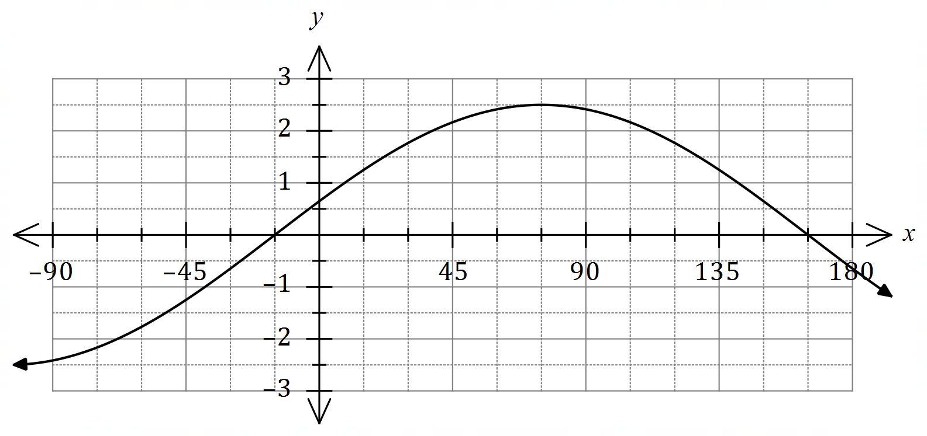
State the value of the constant $a$ and the value of the constant $θ$, $0°≤θ≤180°$.
(2 marks)
Solution
$$a=2.5, θ=75°$$

Specific behaviours
correct amplitude
ü correct phase angle

(b) Show that $\cos{(x+y)}+\cos{(x-y)}=k\cos{x}\cos{y}$ and state the value of the constant $k$.
(2 marks)
Solution
$$\cos\left(x+y\right)+\cos\left(x-y\right)=\cos{x}\cos{y}+\sin{x}\sin{y}+\cos{x}\cos{y}-\sin{x}\sin{y} \\ =2\cos{x}\cos{y}$$

$$k=2$$

Specific behaviours
uses sum and difference identities correctly
ü states correct value of $k$

(c) Determine an exact value for $\cos{75°}+\cos{15°}$. (3 marks)
Solution
If $x=45°$ and $y=30°$ then $x+y=75°$ and $x-y=15°$. Hence

$$\cos{75°}+\cos{15°}=2\cos{45°}\cos{30°} \\ =2×\frac{\sqrt{2}}{2}×\frac{\sqrt{3}}{2} \\ =\frac{\sqrt{6}}{2}$$

Specific behaviours
indicates suitable values for $x$ and $y$
ü uses result from (b) and correct exact values
ü correct, simplified surd

Question 7 (6 marks)
Consider the function defined by $f\left(x\right)=2x^{2}+5$.

(a) Determine $f'(-3)$. (1 mark)
Solution
$$f^{'}\left(x\right)=4x$$

$$f^{'}\left(-3\right)=4\left(-3\right)=-12$$

Specific behaviours
ü correct value

(b) Show that when $x=3$, the expression $f\left(x+h\right)-f(x)$ simplifies to $12h+2h^{2}$. (3 marks)
Solution
$$f\left(3+h\right)-f\left(3\right)=2{\left(3+h\right)}^{2}+5-\left(2{\left(3\right)}^{2}+5\right) \\ =2\left(9+6h+h^{2}\right)+5-18+5 \\ =18+12h+2h^{2}-18 \\ =12h+2h^{2}$$

Specific behaviours
ü substitutes $x+h$ and $x$ into function
ü clearly and correctly expands quadratic term
ü substitutes for $x$ and simplifies

(c) Show use of the result in (b) and the formula $f^{'}\left(x\right)=\lim_{h→0}{\begin{matrix}f\left(x+h\right)-f(x) \\ \overline{ h }\end{matrix}}$ to determine the value of $f'(3)$. (2 marks)
Solution
$$f^{'}\left(3\right)=\lim_{h→0}{\frac{12h+2h^{2}}{h}} \\ =\lim_{h→0}\left(12+2h\right) \\ =12$$

Specific behaviours
uses result as numerator in limit
ü correctly eliminates $h$ from denominator and simplifies limit

Question 8 (7 marks)
The line $y=3x+c$ is a tangent to the curve $y=x^{3}-3x^{2}-6x+7$. Determine the value(s) of the constant $c$.
Solution
Gradient of cubic:
$$\frac{dy}{dx}=3x^{2}-6x-6$$

Gradient of line is $3$ so:
$$3x^{2}-6x-6=3 \\ 3x^{2}-6x-9=0 \\ x^{2}-2x-3=0 \\ \left(x-3\right)\left(x+1\right)=0 \\ x=3, x=-1$$

At $x=3$:
$$y=27-27-18+7=-11$$

$$y+11=3(x-3) \\ y=3x-20⇒c=-20$$

At $x=-1$:
$$y=-1-3+6+7=9$$

$$y-9=3\left(x+1\right) \\ y=3x+12⇒c=12$$

Hence $c=12, c=-20$.

Specific behaviours
gradient function for cubic
ü equates $\frac{dy}{dx}=3$
ü simplifies and factors quadratic
ü both solutions to quadratic
ü $y$-coordinate of point of tangency
ü one value of $c$
ü repeats for second value of $c$

Supplementary page

Question number: _________

© 2020 WA Exam Papers. Kennedy Baptist College has a non-exclusive licence to copy and communicate this document for non-commercial, educational use within the school. No other copying, communication or use is permitted without the express written permission of WA Exam Papers. SN245-162-3.

